

|  |  |
| --- | --- |
| **Cordoba Rewards**  Rewards Management and eCommerce Website | Abstract  The document describes the top-level functionalities of the Cordoba eCommerce & Rewards Management System, Cost Estimate and Development Process  Nitin Patel |

# Objectives

The objective is to develop new rewards platform with integrated eCommerce. The Cordoba Reward platform is already developed and in use by many stores/customers.

The development of the platform started long time ago and it is not time to modernise the platform with latest technologies and new features. Currently end-users buy lots of vouchers and it is essential to provide them better shopping experience and encourage them to buy other products.

# Features

## eCommerce Front End

Implement basic eCommerce system with following features:

* Catalogue (product) Management
* Search product by name, brand, points etc.
* View product details
* View related products
* Shopping Cart
* Secure checkout
* Add/Remove products to shopping cart
* View cart
* Order Management
* Place orders
* View order details, progress status etc.
* Order emails notifications

Customers cannot register directly. Only Admin or Store Admin can add new customers.

## Store Admin

The store admin will have own dashboard with all the detail (i.e. points bought, used, offers using gamification, product recommendation for employees etc.)

* Add individual new store user
* Import multiple store users via excel template
* Manage points – allocate to users, transfer points
* View point’s history
* Store Admin Dashboard (display info which is being sent as part of invoice now)

## Cordoba Admin

* Most of store admin features (e.g. add customers)
* View all stores
* Allocate points to stores/individuals
* Dashboard
* Management Information Report

## Developer Admin

* Set up new store (potentially Cordoba Admin should be able to set up new store as well)
* Advanced reporting

## Advanced eCommerce Features

* Modern design front end for eCommerce
* Display product quick view
* Save product to a wish list
* Promote special products
* Show related products or suggest items
* All users to rate and review products

## Live Chat

Allow customer to chat with Cordoba support staff.

There are plugins we can buy for chatting feature but since we have multiple stores connecting to same support team, customisation may be required.

## Ad-hoc Features

* User should not be able to view products without logging in. Should we have a plain login page? I think it’ll be a good idea have simple landing page with login box.
* **Discounts on site to encourage more procurement orders – need more info**
* Display number of points next to shopping cart icon
* Ability for the users to search products by points instead of price.
* Wish list for concierge service – we will provide a simple page where user can enter product details. On submission, either we can send an email to an admin. If required, we can also start logging this requests in database.
* Add pages – return policy, FAQ, customer service etc.

## Audit/Logs

The system will keep audit of all activities or all users including admins and front store users.

## Front-End Design

We can use modern responsive theme for front-end website. I had a quick look at theme forest for various themes and we can have something like the one in the image below.

**Main Page:**

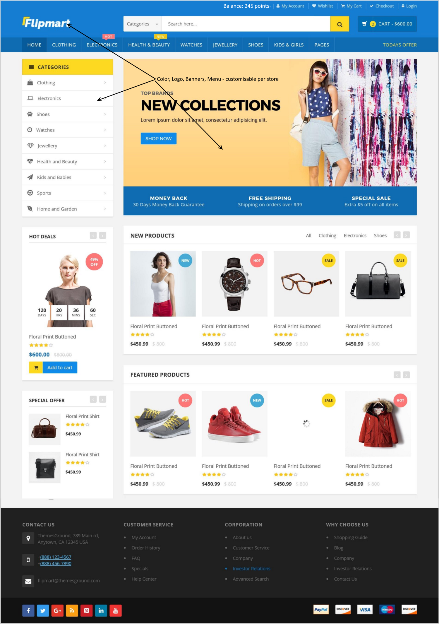

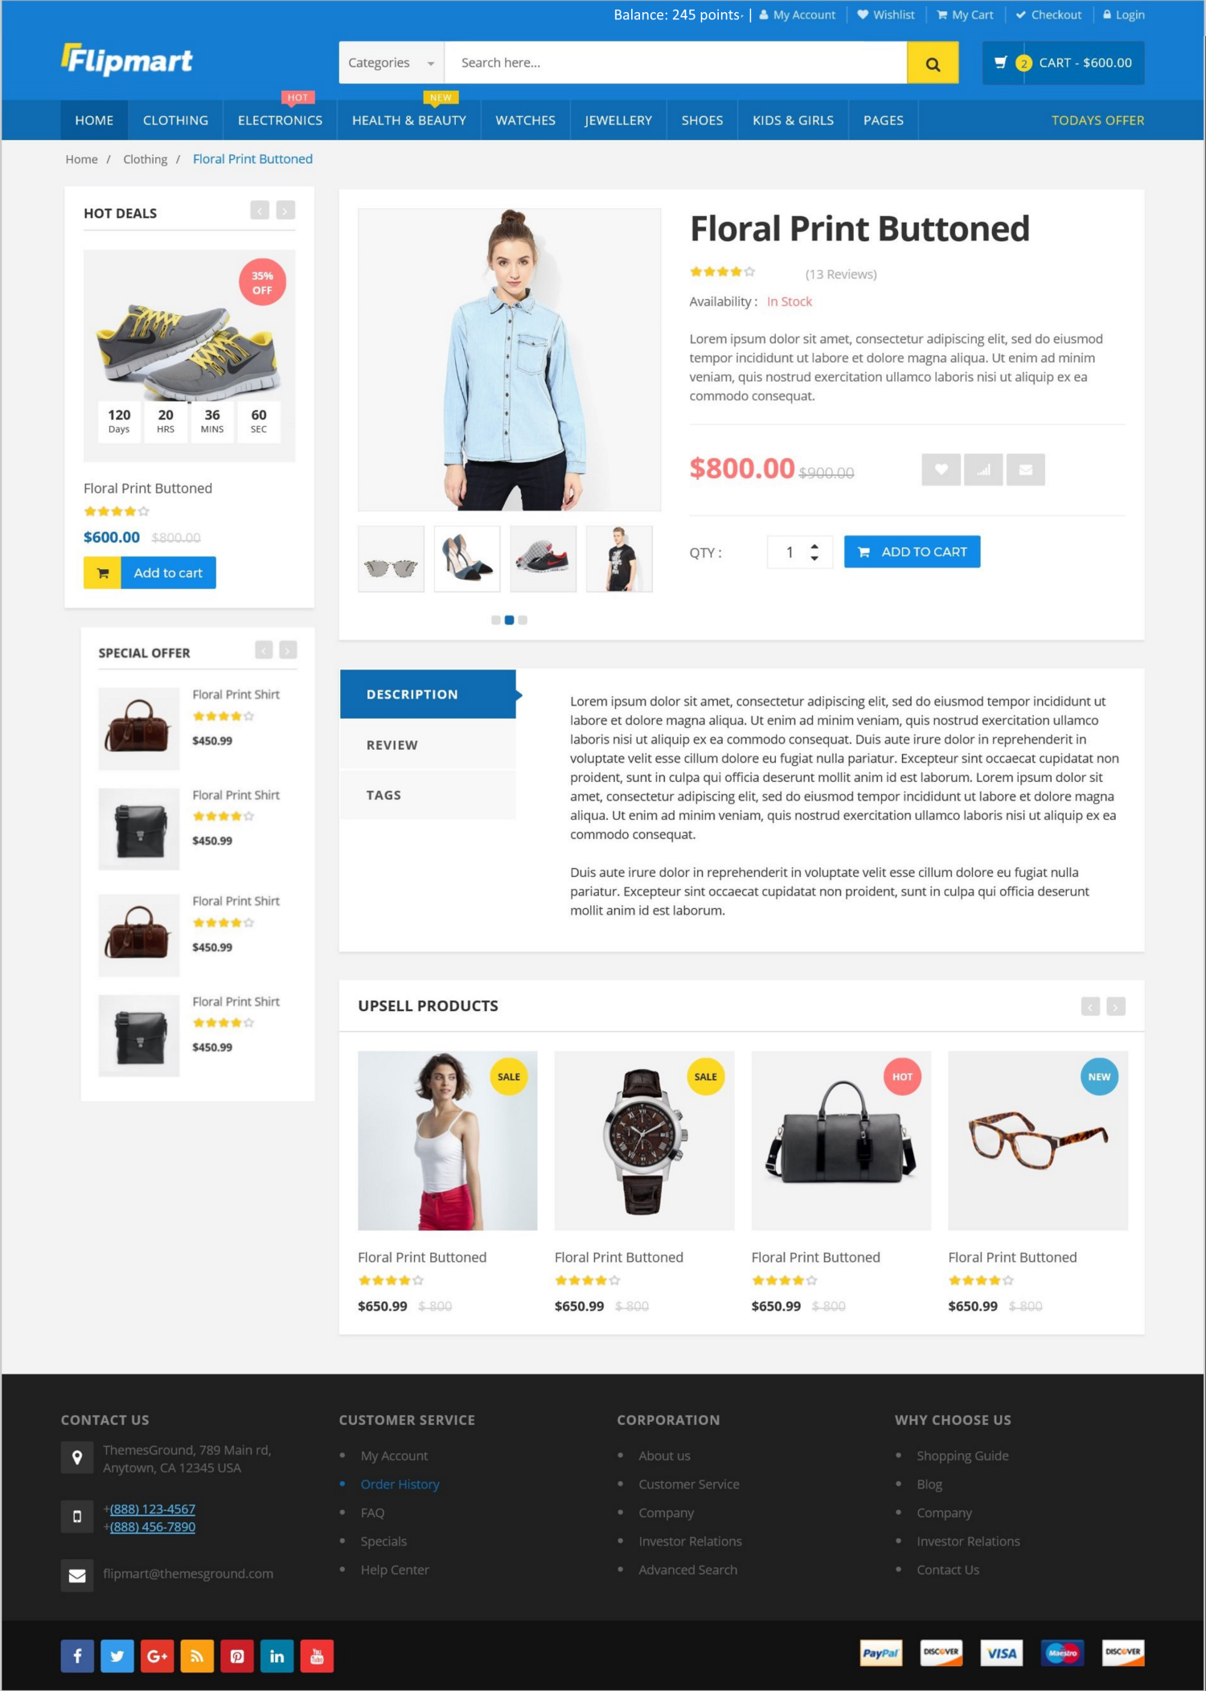

Initially we can develop using one theme but we can easily plugin additional themes – which you can offer to your customers as an added service with bit of an extra cost or as a special offer!

## Gamifications and Rewards Schemes

1. Lucky Draw

For completing specific task or excelling at something, the employee gets entered to lucky draw. The simple game but it can motivate employees to do boring tasks like:

* Feedback Survey
* Company Information Quiz
* Attending Compliance Training Course
* Submitting creative ideas

1. Bingo

<http://work.chron.com/incentive-games-employees-10045.html>

Create an ongoing bingo game that reinforces company policies. Pass out game cards to all employees, who can earn game pieces by showing up to work on time, meeting predetermined production goals or keeping individual work areas clean. As employees black out their game cards, they can choose one of a number of prizes, such as gas cards, lunch with management or sports team tickets. The better the prizes, the higher the employee participation.

1. Raffle

Similar to lucky draw. But here the employee will get a number on achieving a goal. And they can get multiple numbers through the game period.

1. Creativity Context

* Everyone to enter a creative idea/pitch
* Whole team votes on the pitch (except its own)
* Member with highest (and second and third highest) vote wins and gets X points

1. League Table

The employee can get X points on achieving predefined goals. We manage the full table of all points for all employees (or group) through the game period.

<http://technologyadvice.com/blog/sales/3-creative-sales-contest-ideas-and-why-they-work/>

## Technologies & Solution

We propose to develop the new platform using .NET solution with SQL server. With .NET, we can ensure that the solution is more secure and robust then the existing one.

We will follow API based architecture so it will help us to reuse the same business logic for mobile applications in future. (and in future, our customers can set up their own store using our APIs – just if opportunity arises!)